
Mortuaries Crematory Cemetery

Serving
Taos ~ Espanola ~ Santa Fe ~ Los Alamos

We offer our condolences to you at this most difficult time. Over the years we have gained many insights into better serving those experiencing the loss of a loved one. We realize the trust you have placed in our funeral home, and we are responsible for following through with your wishes. All conversations are held in the strictest of confidence. Please feel assured that we will assist you in planning dignified arrangements with your budget in mind. We are proud to say that we are a locally family owned & operated business and not affiliated with any large out of state funeral corporation, therefore we are able to offer our professional services at a lower cost to you.

Licensed Funeral Directors
Amos Rivera Tim Rivera Matthew Rivera Robert Clifford

Funeral Service Interns
Raymond Lucero Danielle Silva Paul Vigil
Doreen A. Martinez Joaquin Gonzales Margaret Bryant
Mary Helen Perea Chris Vega Al Vincent Romero

PAYMENT POLICY
Payment in full is required at the time of arrangements

Rivera Family Funeral Homes

Taos Santa Fe Espanola

GENERAL PRICE LIST

This prices are effective as of February 01, 2014, but are subject to change without notice

Ask about the savings on our package plans

ITEMIZED SELECTIONS

The goods and services shown below are those we can provide to our customers. You may choose only the items you desire. However, any funeral arrangements you select will include a charge for our basic services and overhead.
If legal or other requirements mean you must buy any items you did not specifically ask for, we will explain the reason in writing on the statement we provide describing the funeral goods and services you selected.

PROFESSIONAL SERVICES

Basic Services of Funeral Director and Staff $1,860
Our fee for the services of funeral director and staff includes, but is not limited to, staff to respond to initial request for service, arrangement conference with family or responsible party: arrangement of funeral/services, preparation and filing necessary authorizations and permits; recording vital statistics, preparation and placement of obituary notices; staff assistance prior to, during and following the funeral/services, including coordination with those providing other portions of the funeral, e.g. cemetery, crematory and others. Also included in these charges are overhead expenses relative to our facilities such as insurance, maintenance and utility expenses, secretarial and administrative costs, equipment and inventory costs.

This fee for our basic services and overhead will be added to the total cost of the funeral arrangements you select. This fee is already included in our charges for direct cremations, immediate burials and forwarding or receiving remains.

Embalming $900
Except in special cases, embalming is not required by law. Embalming may be necessary, however if you select certain funeral arrangements, such as a funeral with a viewing. If you do not want embalming, you have the right to choose an arrangement which does not require you to pay for it, such as direct cremation or immediate burial, state law requires embalming or refrigeration beyond 24 hours from time of death.

Dressing and/or Casketing of Remains $185
Cleansing, shaving, washing/conditioning hair, cosmetology/makeup, minimal restorative art, dressing and casketing (or any portion thereof)

Dressing/Bathing/Care of Unembalmed Remains $205

Special Care for Autopsied Remains/Organ Donation (Additional) $105

Processing of death certificate $310

Disinterment (does not include opening/closing of grave and lowering device) $1500
Does not include any merchandise or disposal of casket or any cash advances

USE OF FACILITIES, STAFF AND/OR EQUIPMENT

Crematory Fee $300

Refrigeration (first day thereafter $100 per additional days) $275

Shelter of Remains $105

Identification of Remains in viewing room (20 minutes, 6 people maximum, legal next of kin only) $320

Use of Facilities for Ritual Bathing and Shrouding (Tahara) $415

Viewing/Visitation (per day or portion thereof) $500
Our services include set-up of visitation area, placement of encased remains, and display of floral arrangements, supervision of and attendance during the visitation.

Funeral Ceremony in our Chapel or other location $800
Our services include coordinating the funeral arrangements, necessary staff, equipment and supervision, etc.

Memorial Ceremony in our Chapel or other location $800
Our services include coordinating the memorial ceremony, necessary staff and supervision, equipment, etc.

Evening Service in our Chapel or other location $800
Our services include coordinating the evening service, necessary staff and supervision, equipment, etc.

Video Set-Up at off site location $225

Reception at Rivera Chapel (Clean up) $160

Graveside Service $310
Our services include accompaniment of remains to cemetery, any necessary equipment and supervision.

Facilities and Staff $105
Per hour charge for staff and/or use of facilities or equipment for partial ceremonies, anatomical donations, or other items not included in the above charges.

TRANSPORTATION

Transfer of deceased to funeral home (local) $525

Funeral Coach (local) per use $570

Service/Delivery Vehicle (local) per use for flowers, vaults, etc. $105

Added Transportation Fee (Per mile one way) $2.75

Transportation Fee to/ from Albuquerque $160

Stretch Limousine (within county) $325

Transportation of lowering device, cemetery equipment, etc. (within city limits-additional charges out of city limits) $260
Cemetery equipment including casket lowering device, planks/boards for minimal structural support, chairs for family members and canopy during inclimate weather. PLEASE NOTE **OPEN GRAVES ARE DANGEROUS!
Rivera Family Funeral Homes, assumes no liability for accidents or injury resulting from dangerous open graves conditions.

Partial cemetery equipment without lowering device for cremation $125

DIRECT CREMATIONS

This charge includes removal of remains, transportation to crematory and basic services of staff. This charge does not include any rites or ceremonies. If you want to arrange a direct cremation, you can use an alternative container. Alternative containers encase the body and can be made of materials like fiberboard or composition materials (with or without an outside covering). The containers we provide are heavy cardboard and wood. EMBALMING, REFRIGERATION, FACILTY FEE, ID OR OMI PERMIT NOT INCLUDED.

Direct cremation with alternative container for body and urn selected /provided by purchaser $2,265

Direct cremation with minimal alternative container for body included-urn not included $2,500

Direct cremation w/ alternative container for body & minimal container for cremated remains $2,600

Direct cremation w/ alternative container for body & minimal container for cremated remains.
(Includes refrigeration) $2,805

REFRIGERATION $275 (first day) $105 additional days EMBALMING $825

OMI Cremation Permit $150

ALTERNATIVE/MINIMAL CREMATION TRAY ID CREMATION TRAY
STANDARD $230 OVERSIZE $335 $310

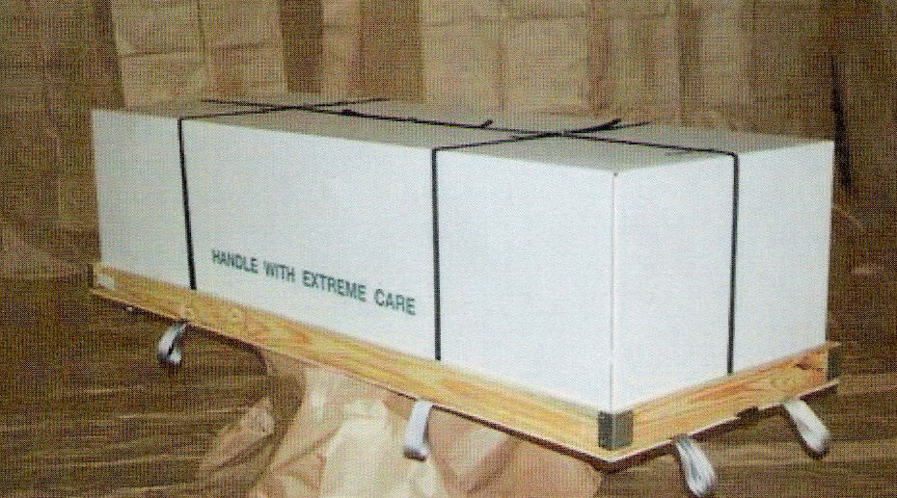
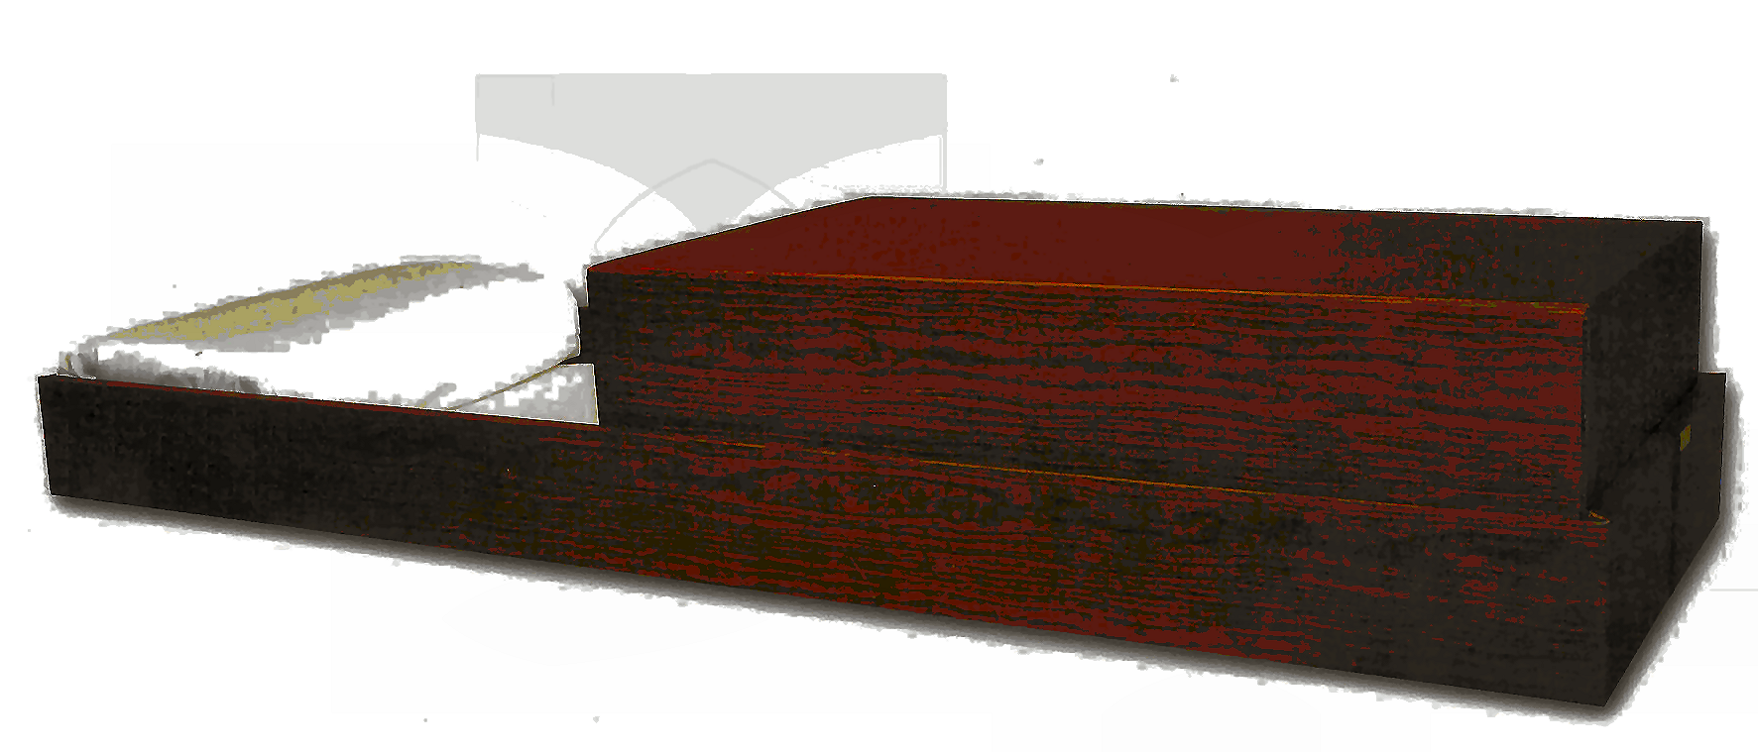
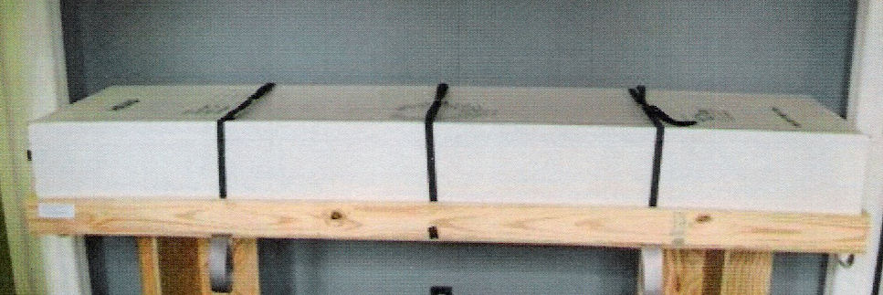 WICKER CASKET

WICKER NORFOLK LAMINATE
$1000 $2030
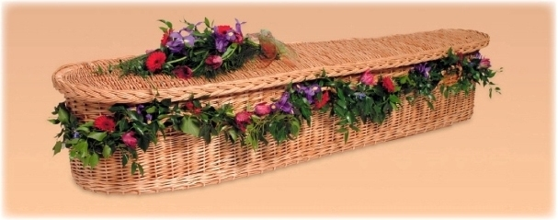
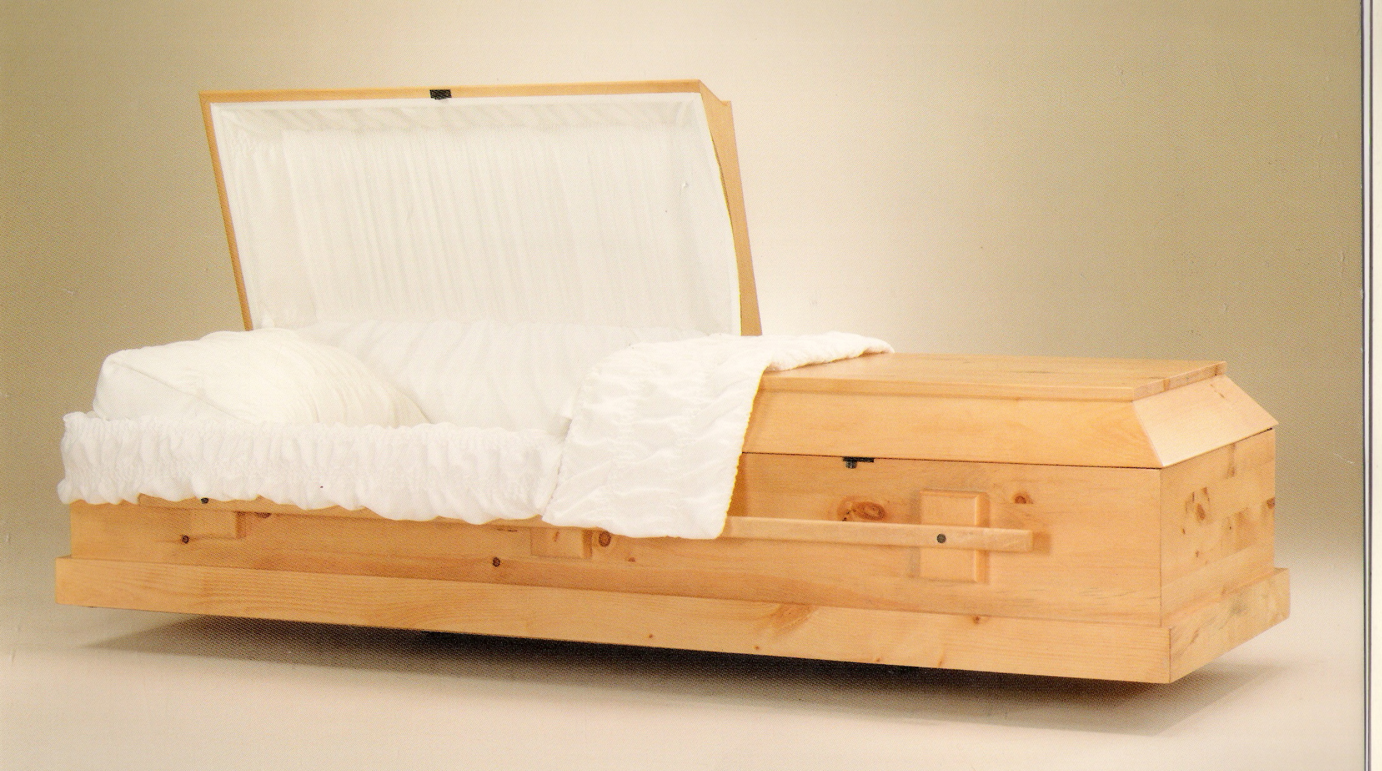

ONLINE CREMATION PACKAGE $995-$1225
Only available on online—not available at any funeral home location
- Arrangements must be made online only (there is no in-house consultation)
- Payment in full at time of online arrangement is required to take advantage of this package

Go to www.cremationsnm.com for more information and to arrange for cremation.

Cash advances to cover the cost of cremation permit, certified copies of death certificates and tax will be charged in addition to the package.

Online direct cremation with alternative container for body and urn selected /provided by purchaser $ 995

Online cremation with minimal alternative container for body included-urn not included $1,225
FORWARDING REMAINS TO ANOTHER FUNERAL HOME

This charge includes local removal of remains, basic services of staff, embalming, necessary authorizations and transportation to Albuquerque airport. This charge does not include casket, airline fees, any rites or ceremonies, consulate fees or cash advances.

With minimum combo shipping container $1,960

Orthodox Ship-Out with container and gel packs (in lieu of embalming) $1,960

With casket selected from our funeral home (in addition to the cost of the casket) $1,750

Air Tray $205

Consulate Administrative Fees (paper work for international shipments) $525

RECEIVING REMAINS FROM ANOTHER FUNERAL HOME $1,960
This charge includes basic services of staff, transportation from Albuquerque airport, transportation of remains to cemetery and cemetery equipment. This charge does not include extra mileage visitation, rites, ceremonies, cash advance items, etc.

IMMEDIATE BURIALS

The charge for immediate burial includes local removal of remains, transportation to local cemetery, necessary authorizations, basic services of staff and cemetery equipment. This charge does not include the use of facilities and staff for any visitation or ceremony, public or private, prior to burial. This charge does not include embalming.

Immediate burial and transportation to cemetery (with casket selected from our funeral home) $2,680

Immediate burial and transportation to cemetery (with casket provided by family) $3,200

Immediate burial with gray cloth-covered soft wood casket selected from our funeral home $3,710

BURIAL WITH GRAVESIDE SERVICE $3,250
This charge includes local removal of remains, transportation to local cemetery, necessary authorizations, basic services of staff and cemetery equipment. This charge includes the use of facilities and staff for any visitation or ceremony, public or private, prior to burial. This charge does not include embalming or casket/container.

ORTHODOX BURIAL WITH GRAVESIDE SERVICE $4,730
This charge includes local removal of remains, transportation to local cemetery, necessary authorizations, basic services of staff and cemetery equipment. This charge includes orthodox pine casket, use of facilities and staff for Tahara, candles and ribbons. This charge does not include embalming or shroud.
.

DISINTERMENT
Disinterment (does not include opening/closing of grave and lowering device) $1500
Does not include any merchandise or disposal of casket or any cash advances

MERCHANDISE AND MISCELLANOUS
A complete list of caskets, outer burial containers and urns are available at the funeral home.

Caskets $1030-$9.650

Head Panel Insert $150

Rental Casket (Ceremonial) $720

Urn Carriage $200

Minimal Cremation Tray $230

Oversize Cremation Tray $335

Starmark ID Cremation Tray $310

Casket Insert $70-$155

Outer Burial Containers $620-$1030

Cremation Urns $130-$1465

Temporary containers for cremated remains $65-$115

Mini Blooming Remembrances (crosses, hearts, butterflies) per 100 $160

Combination Shipping Containers (ATA Approved) $310

Air Trays for Shipping Caskets (ATA Approved) $205

Disaster Pouch $310

Ziegler Case $720

Candle $10

Prayer Cards (per 100) $75

Prayer Cards with Picture (additional fee) $35

Memorial Folders (per 100) $105

Memorial Folders with Picture (additional fee) __ $35

Guest Register Book $35

Crucifix/Cross $25

Temporary Grave Marker $30

Acknowledgment Cards (box of 25) $15

Memorial Package $235
Includes guest register book, acknowledgment cards, 200 prayer cards or 100 memorial folders without picture (picture extra charge), one cross, one candle, temporary grave marker, production of video (20 pictures and one song). Additional charge for extra prayer cards/memorial folders.

OTHER

Jewish Shroud $105

Flag Cases $125-$400

Tents Quoted by size

Packaging and mailing of cremains (not including urn and depending on weight) $95

Shipment of urn (approx. depending on weight)

Disposal of personal effects $30

Death certificates-per copy (up to 3 months from death) $5

Monument setting (price reflective upon size, location, etc.)

Obituary on Website $75

Obituary (approx. depending on size) varies

Obituary (Out of Town) per notice (does not include newspaper charge) $30

Obituary (International) per notice (does not include newspaper charge) $75

Radio Announcement $25

St. Francis Cathedral Deacon $25

Engraving urn (standard-name and date) varies

Engraving urn (custom design) varies

Video ($25 discount if picture are on a disk) $175

Video (Additional Copies) $25

Search Fee (per transaction) $20

Consulate Administrative Fees (paper work for international shipments) $525

Rosaries Price Varies

Urn Price List

These prices are effective as of February 01, 2014, and are subject to change without notice.

 | Double Capacity Bronze or Wood Finish | $715
 | Tiger Eye Marble Jar | $530
 | Cloisonne | $530
 | Mother of Pearl Bronze | $530
 | Mahogany/Cherry | $490
 | Fired Clay Pottery | $450
 | Solid Copper Cylinder | $435
 | Himalayan Rock Salt | $435
 | Oak or Cultured Marble | $385
 | Simple Birch Wood  Cornstarch eco-urn | $385  $385
 | Solid Walnut or Aromatic Cedar | $385
 | Ocean Sand | $385
 | Ocean Sand Keepsake | $190
 | Simple Birch Wood | $350
 | Keepsake Urns | $105

*Engraving*
Name/Date $50
Standard Design $40
Custom Design $70
Apllique/Medallion $50
Overnight Shipping $50

Minimal Temporary Containers for Cremated Remains

Tube Urns $115
Reflect Earthurn (Silk & Handmade Natural Fibers) $115
Embrace Earthurn (Handmade Natural Fibers) $115
Unity Earthurn (Handmade Natural Fibers) $115
Journey Earthurn (Handmade Natural Fibers) $115

OTHERS/ Keepsake containers
pendant with chain varies

DISCLAIMER OF WARRANTIES
RIVERA FAMILY FUNERAL HOMES MAKES NO REPRESENTATIONS OR WARRANTIES REGARDING THE URNS LISTED ABOVE. THE ONLY WARRANTIES, EXPRESSED OR IMPLIED, GRANTED IN CONNCECTION WITH URNS SOLD ARE THE EXPRESS WRITTEN WARRANTIES, IF ANY, EXTENDED BY THE MANUFACTURES THEREOF. RIVERA FAMILY FUNERAL HOMES HEREBY EXPRESSLY DISCLAIMS ALL WARRANTIES, EXPRESSED OR IMPLIED, RELATING TO THE URNS, INCLUDING BUT NOT LIMITED TO THE IMPLIED WARRANTIES OF MERCHANTABILITY AND FITNESS FOR A PARTICULAR PURPOSE.

SANTA FE CASKET PRICE LIST

These prices are effective as of February 01, 2014 and are subject to change without notice.

PIETA COPPER-precious metal, solid copper, velvet interior $9,650

GATEWOOD PREMIER CHERRY- polished solid cherry, velvet interior $6,890

GOLDEN MIDNIGHT-18 GA steel, velvet interior $5,650

CHAMPAIGN ROSE STAINLESS STEEL-velvet interior $5,490

SOLID CEDAR-solid cedar, linen interior $5,090

HEARTHSIDE OAK –rosetan crepe interior $5,090

PROVINCIAL POPLAR-rosetan crepe interior $5,090

SPRINGFIELD--18 ga steel, crepe interior $4,300

AFFINITY-Light Gunmetal 20 GA steel, white crepe interior $3,600

WHITMIRE II-veneer poplar, rosetone crepe interior $3,400

SIERRA-Gold/bronze 18 GA steel, rosetan crepe interior $3,400

OUR LADY OF GUADALUPE – blue finish 18ga steel, crepe interior $3,400

STERLING-white or blue finish, 18 gauge steel, crepe interior $3,400

ESSEX-Ebony mirror finish, 20 GA steel, crepe interior $3,400

SHELLBROOK VENEER-particle board, crepe interior $2,950

VALENCIA (BROWN, ORCHID, WHITE, BLUE)-lightweight 20ga steel, crepe interior $2,880

BELVEDERE-lightweight 20 Gauge Steel, crepe interior $2,090

NORFOLK (PARTICLE BOARD W/PINE LAMINATE) $2,090

WICKER $1030-$1670

ORTHODOX PINE-(UNLINED FLAT TOP) $1030

DENTON RAISED OVAL TOP-Hercu-lite, cloth covered, twill interior $1030

STARMARK TRANSPORTER ID CONTAINTER $ 390

DISCLAIMER OF WARRANTIES
RIVERA FAMILY FUNERAL HOMES MAKES NO REPRESENTATIONS OR WARRANTIES REGARDING THE CASKETS LISTED ABOVE. THE ONLY WARRANTIES EXPRESSED OR IMPLIED, GRANTED IN CONNECTION WITH CASKETS SOLD ARE THE EXPRESS WRITTEN WARRANTIES, IF ANY EXTENDED BY THE MANUFACTURERS THEREOF. RIVERA FAMILY FUNERAL HOMES HEREBY EXPRESSLY DISCLAIMS ALL WARRANTIES, EXPRESSED OR IMPLIED, RELATING TO THE CASKETS, INCLUDING BUT NOT LIMITED TO THE IMPLIED WARRANTIES OF MERCHANTABILITY AND FITNESS FOR A PARTICULAR PURPOSE.

OUTER BURIAL CONTAINER PRICE LIST

These prices are effective as of February 01, 2014, and are subject to change without notice.

In most areas of the country, state of local law does not require that you buy a container to surround the casket in the grave. However, many cemeteries require that you have such a container so that the grave will not sink in.
Either a grave liner or a burial vault will satisfy these requirements.

1. STEEL VAULT-12ga, sealer type, air seal type $1,620

2. ABS PLASTIC VAULT $700

3. PEBBLE URN VAULT $480

4. UNIVERSAL URN VAULT $480

5. TRIPLE H OVERSIZE URN VAULT $325

DISCLAIMER OF WARRANTIES
RIVERA FAMILY FUNERAL HOMES MAKES NO REPRESENTATION OR WARRANTIES REGARDING THE OUTER BURIAL CONTAINERS LISTED ABOVE. THE ONLY WARRANTIES, EXPRESSED OR IMPLIED, GRANTED IN CONNECTION WITH THE OUTER BURIAL CONTAINERS ARE THE EXPRESS WRITTEN WARRANTIES, IF ANY, EXTENDED BY THE MANUFACTURERS THEREOF. RIVERA FAMILY FUNERAL HOMES HEREBY EXPRESSLY DISCLAIMS ALL WARRANTIES, EXPRESSED OR IMPLIED, RELATING TO THE OUTER BURIAL CONTAINERS, INCLUDING, BUT NOT LIMITED TO, THE IMPLIED WARRANTIES OF MERCHANTABILITY AND FITNESS FOR A PARTICULAR PURPOSE.

